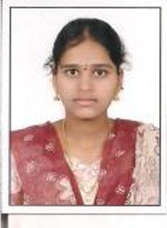

Ch.Sai Mounika

Sai Harini`s Pride,

Road No:4, Anjaneeya Nagar,

Moosapet , Hyderabad

**Career Objective**

An enthusiastic, result oriented and self disciplined individual seeking an opportunity for a job to play a challenging role in organizations growth and to grow with the organization.

**Project Details**

**1st Project**

**Project Title:** Camera Live Streaming

**Technology Used:** Wireless Communication

**Frame Work:** BeagleBone Black

**Project Description:** Streaming of live videos using BeagleBone Black.

**2nd Project**

**Project Title:** Chopper Controlled DC Motor

**Technology Used:**

**Frame Work:**

**Project Description:** Controlling the speed of a dc motor using chopper.

**Educational Qualification**

|  |  |  |  |  |
| --- | --- | --- | --- | --- |
| **Qualification** | **Stream** | **Year of Passing** | **University/Board** | **Percentage** |
| B.Tech | ECE | 2016 | JNTUH | 69.00 |
| XIIth | MPC | 2012 | Intermediate Board | 87.70 |
| Xth |  | 2010 | State Board | 79.50 |

**Certification**

I am currently undergoing training from NIIT for Digital Transformation

* Training includes following modules :
* **Internet Technology :** HTML, JavaScript and XML
* **Core Java:** JVM, packages, Interface, Threads, Applets, swing, generics.
* **Specialized Technology:** Advanced Java: JSP and Servlets.
* **Database:** H2
* **Soft Skills:** Training regarding how work in Corporate World with standards, rules,  discipline and subject knowledge.

**Technical Skills**

* **Languages:**  Core [java](http://myjobsresumes.blogspot.in/2013/07/cv-for-java-developers.html), HTML, C
* **OS Environment:**  Windows 2000/XP/7/10, DOS.
* **Tools:** Eclipse

**Extra-Curricular Activities**

* **GitHub Link** - https://github.com/saimounika9512/mounika.git

**Personal Strengths and Achievements**

* Proven strength in problem solving coordination.
* Self-confident, quick learner.
* Ready to work at any given circumstances and as a team player.
* Ability to learn from self-mistakes and adjusting with people of any type.
* Good communication and organization skills.

**Personal Dossier**

* **Father’s Name :** Ch.Rama Krishna
* **DOB :** 12th April, 1995
* **Passport Number:** NA